**PRESENTER GUIDELINES**

**How to Create Video Presentation on ICEE 2023: A Tutorial**

1. The video presentation should follow these rules:

|  |  |  |  |  |
| --- | --- | --- | --- | --- |
|  | **Information** | |  |  |
| **Duration** 5-7 minutes | **Features**  Power Point Presentation and the voice of presenter should with/without show of face | **Video**  **Format**  Mp4 | **Size**  Less than 40 MB | **Max.**  **Slide**  7 |

1. Please include the following items in your PPT as follows: *Title, Background, Method, Results and Discussion,* and *Conclusion.*
2. Presenters are welcome to use different types of software application to create video. But it is suggested for using ***ZOOM SOFTWARE***. You can follow the tutorial below.
3. The presenter is suggested to use a virtual background provided by the committee. It can be downloaded at https://icee.upi.edu/2023/info/download

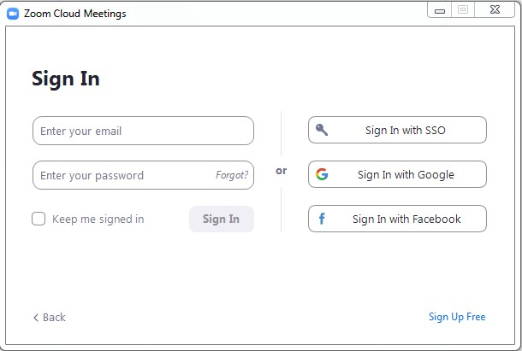

1. Tutorial of recording video by using zoom meeting application:
   1. Make sure that you have a zoom application on your laptop or computer. You can download it from [https://zoom.us/download.](https://zoom.us/download)
   2. Sign in to your Zoom Account or use your Google Account.
   3. Setting (***gear icon***).

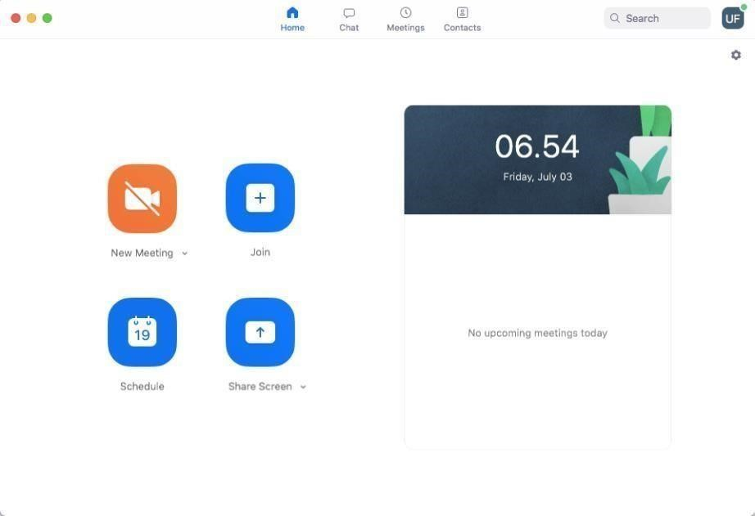

* 1. Click the **Video** and make sure that the camera is working. To check the camera on your computer, please **check** the click button on your camera setting.

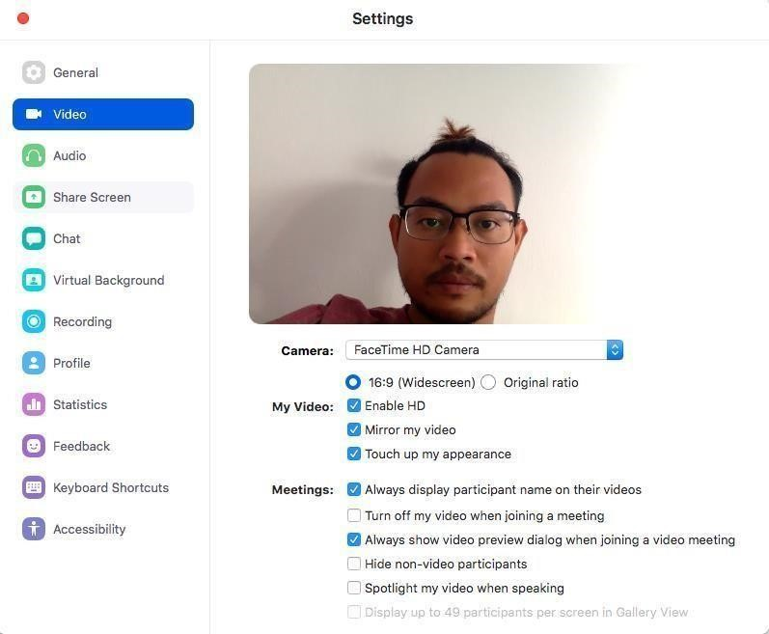

* 1. **Audio**, ensure that the Audio is working. To check the audio, click the **Test Mic**.

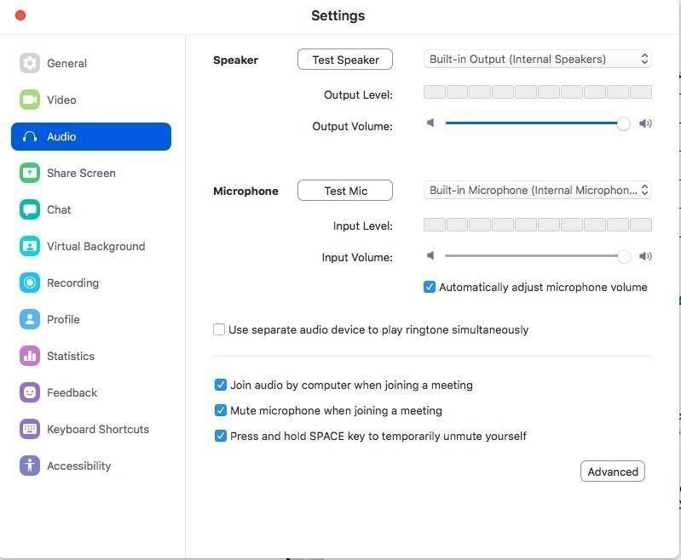

* 1. Click **share screen** and make sure that your share screen can be opened.

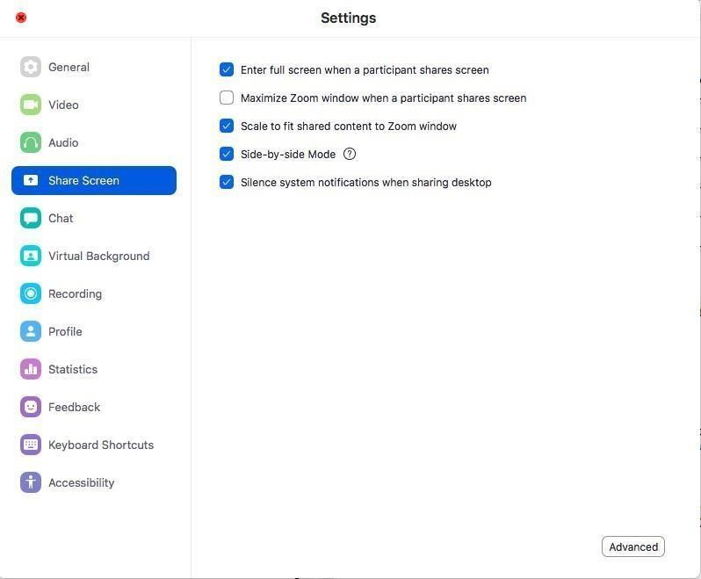

* 1. **Recording**, ensure that the option of **record during screen sharing** is On.

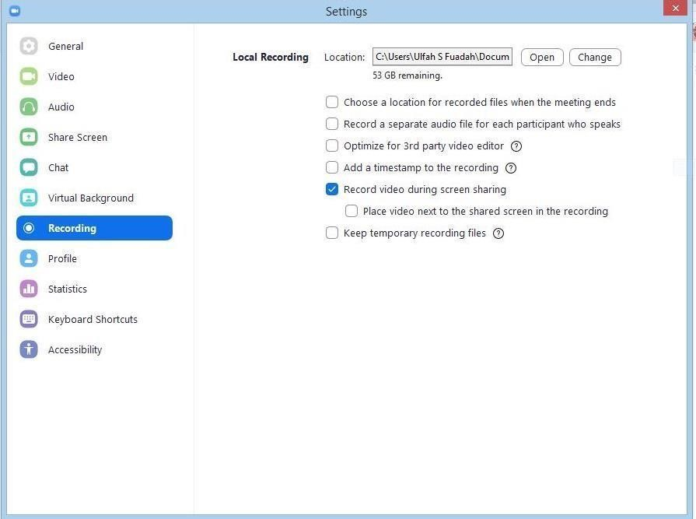

* 1. Back to home page and you can start a **New Meeting.**

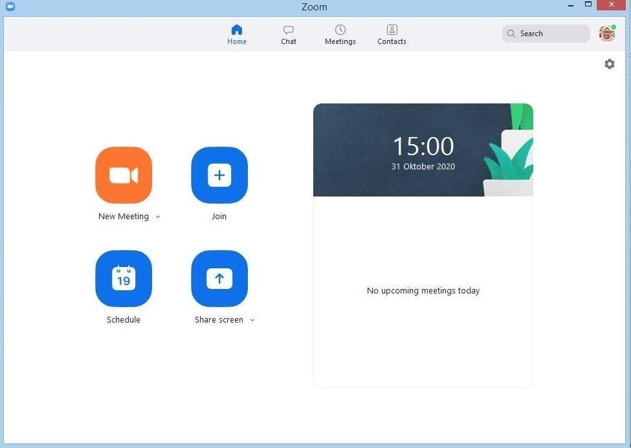

* 1. Make sure that the **Audio and Video** on zoom meeting application is on.

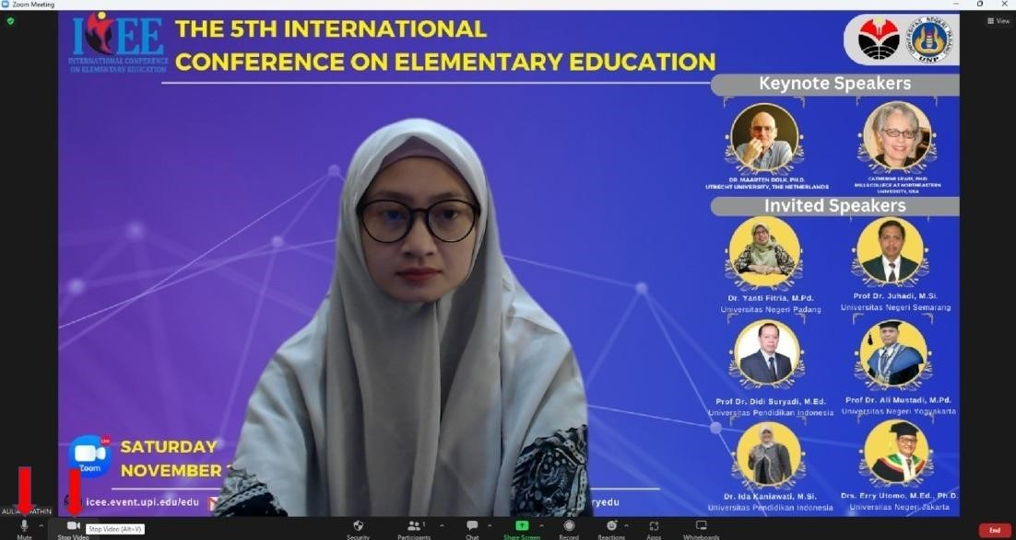

* 1. Klik **Record** button to start recording. Now, you can start sharing your presentation and started by introducing yourself.

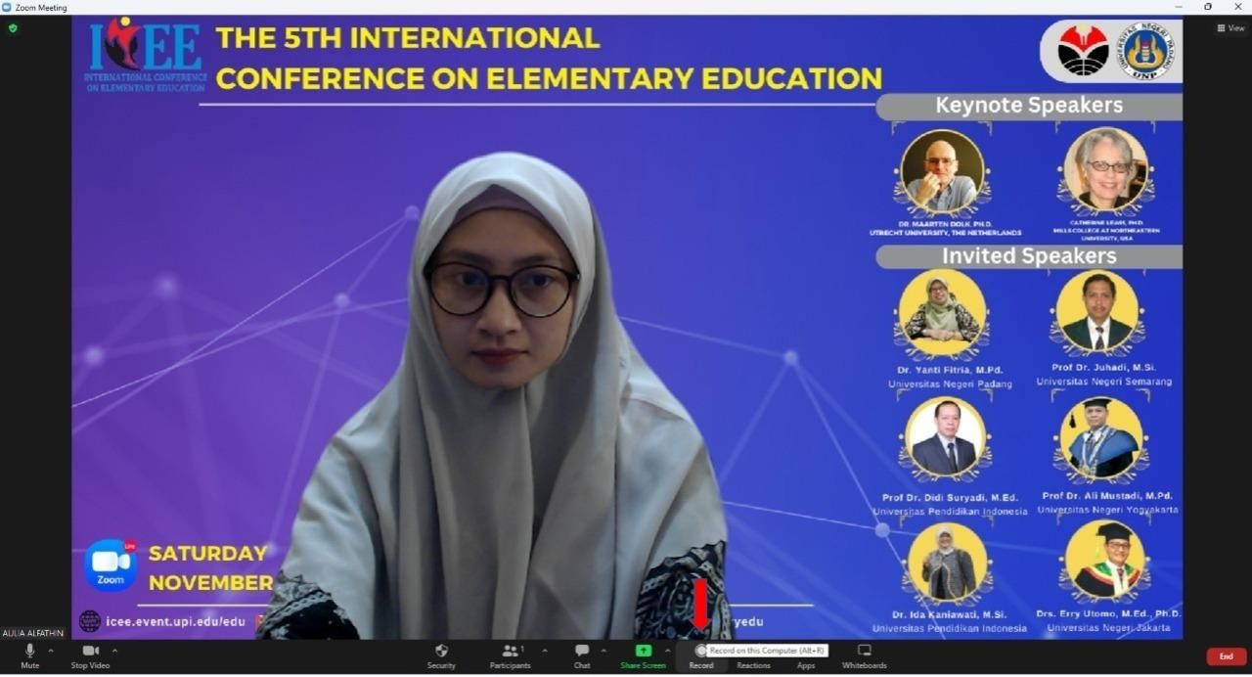

* 1. Click the **Share Screen** and find your PPT (ensure that your PPT file was opened before).

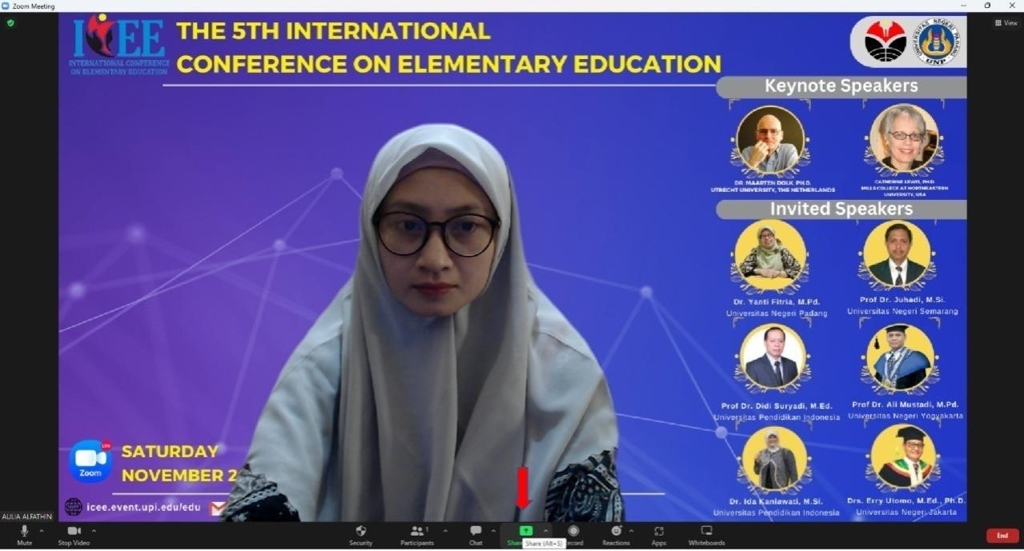

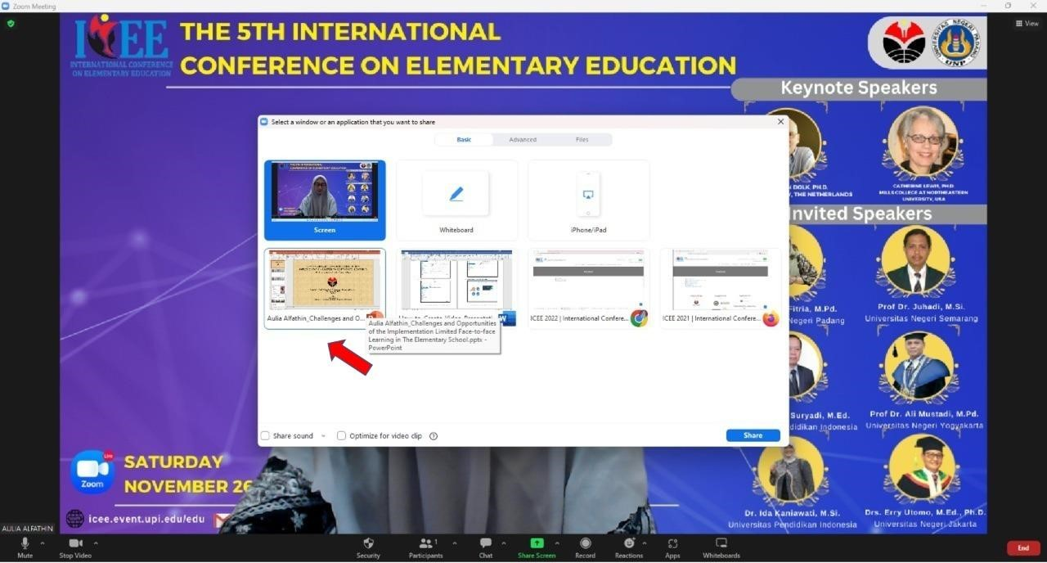

1. Your screen already changed with your PPT screen and your camera on the right top.

Start your presentation with up to 8 minutes (maximal).

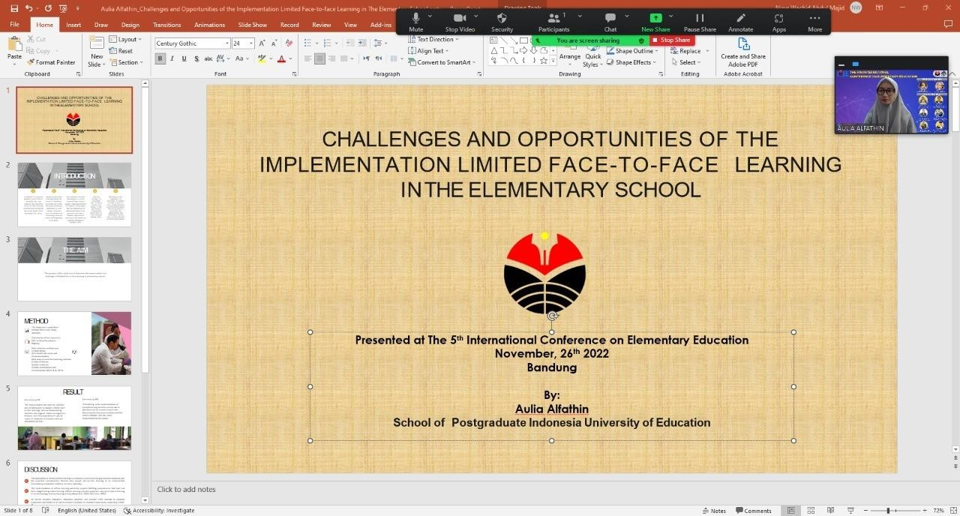

* 1. If you finish your presentation, you can click **Stop Share**, click **Stop Recording**, and then continued by **clicking End Meeting for All.**

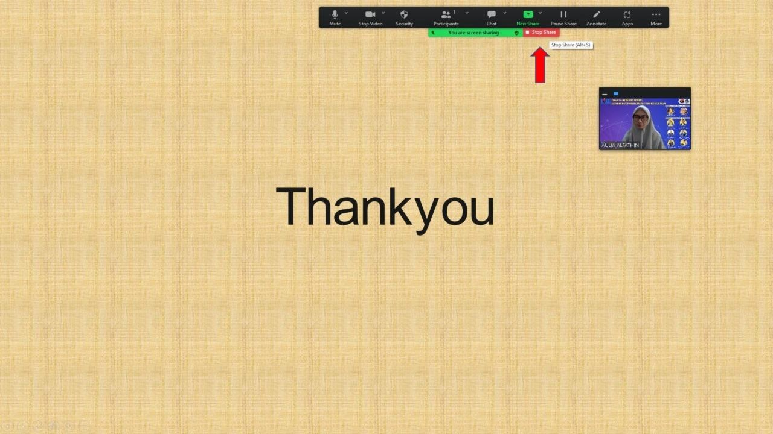

* 1. Zoom will convert your recording file into 3 types of files, open your folder and search those files to make sure your recording is saved.
  2. Please ensure that your video format is **.mp4**.
  3. Please rename the video file into: **Video_Author_Title Example: Video_Gitta Bella_Gender Identity Perspecttive Analysis of Narrative Text Illustrations on th 4th Grade Elementary School’s 2013 Curriculum Instructional Materials**
  4. The last, fill out the presenter preparation form and upload your video presentation into the link: https://bit.ly/PresenterPreparationForm

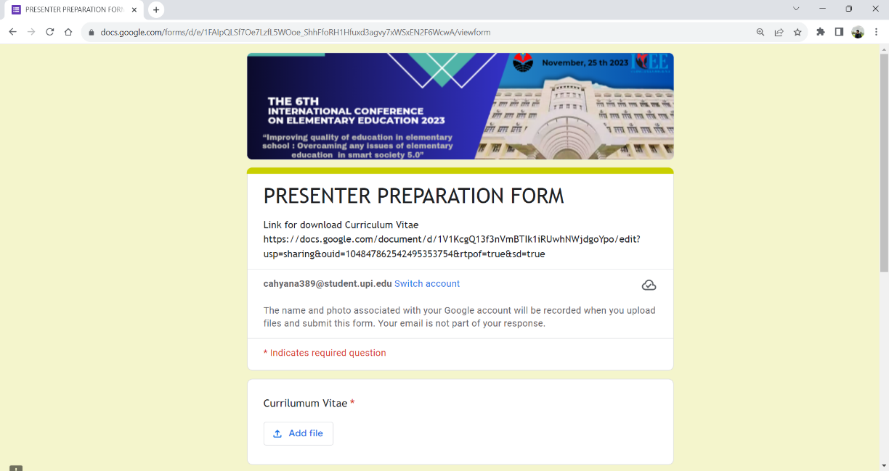

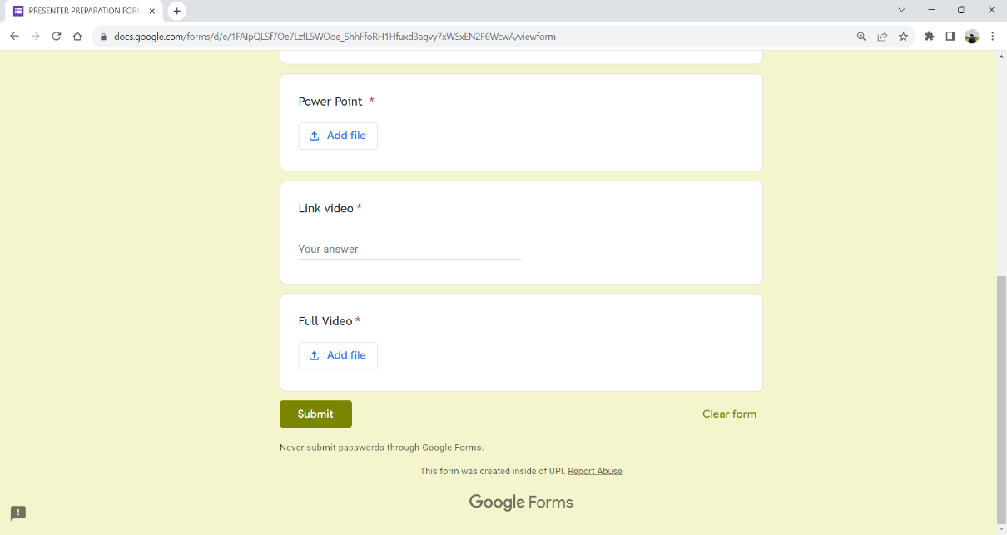

1. For more information, please watch video tutorial on the link below. Link:

[http://icee.event.upi.edu/2022/info/How_to_Create_Video_Presentation_ICEE_2023:](http://icee.event.upi.edu/2022/info/How_to_Create_Video_Presentation_ICEE_2023:%20) [_a_Tutorial](http://icee.event.upi.edu/2022/info/How_to_Create_Video_Presentation_ICEE_2022:_a_Tutorial)

1. The deadline to upload the video presentation is on **November 22th, 2023*.***